A000-Am, S-Colombia-Tairona-Tumbaga-Woman kneeling with hands on her abdomen-1000-1500 CE

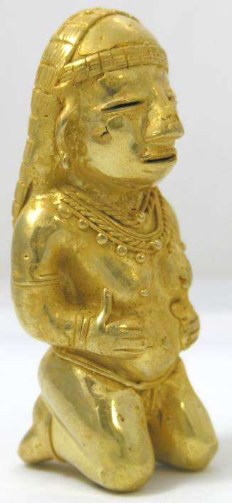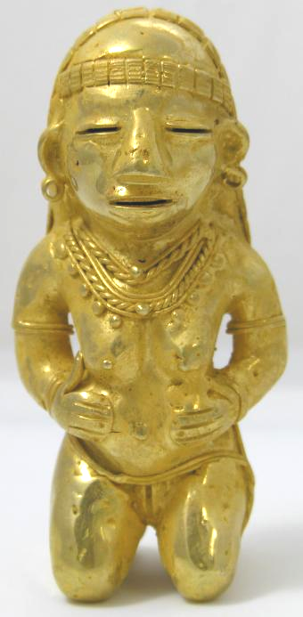

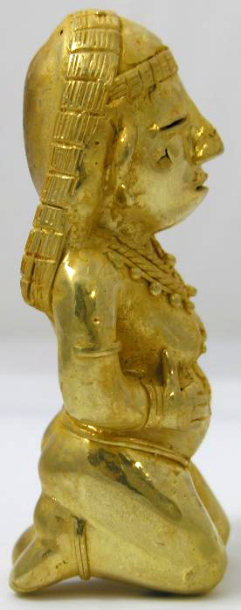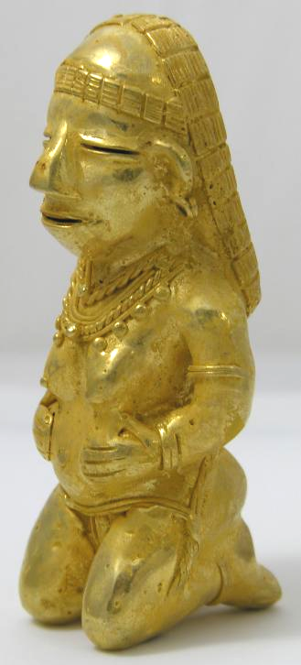

Figs. 1-4. Colombia-Tairona-Tumbaga-Woman kneeling with hands on her abdomen-1000-1500 CE

Case No.: 7

**Accession No.**

**Formal Label:** Colombia-Tairona-Tumbaga-Woman kneeling with hands on her abdomen-1000-1500 CE

**Display Description:**

**Various aspects of childbirth are accorded sensitive treatment by the Tairona. This figurine appears to provide an empathetic view of the early pangs of childbirth.**

**LC Classification:**

**Date or Time Horizon:**

**Geographical Area:**

**Map:**

**GPS coordinates:**

**Cultural Affiliation:**

**Media:**

**Dimensions:**

**Weight:**

**Condition:**

**Provenance:**

**Discussion:**

**References:**



  
  